CHAPTER 6: The mysterious universe
Worksheet 6.1

Observing stars
Answers
1. Three types of celestial objects are illustrated below. Identify and outline the nature of each.
(a) | 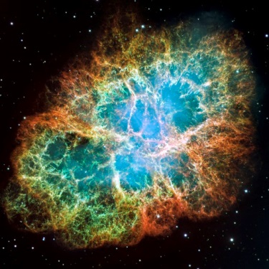 | Name: Nebula  Nebula  Nebula  Clouds of gas and dust that can come together and heat up to form stars  Outline:
(b) | 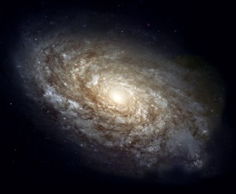 | Name: Galaxy  A group of stars and gas held together by gravity  Galaxy  Outline: A group of stars and gas held together by gravity
(c)  Photos:  Top: creativemarc / 123RF  Centre: NASA, Hubble Heritage Team, STScI  Bottom: Yuri Beletsky / NASA | 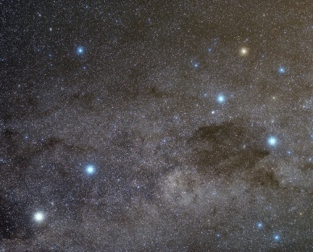 | Name: Constellation  Outline: A region of stars that form a pattern when viewed from Earth
CHAPTER 6: The mysterious universe
Worksheet 6.1

Page 2

2. The following diagram shows the effect of parallax on the observation of a close star (S) from two locations (X and Y) in the Earth’s orbit around the sun.
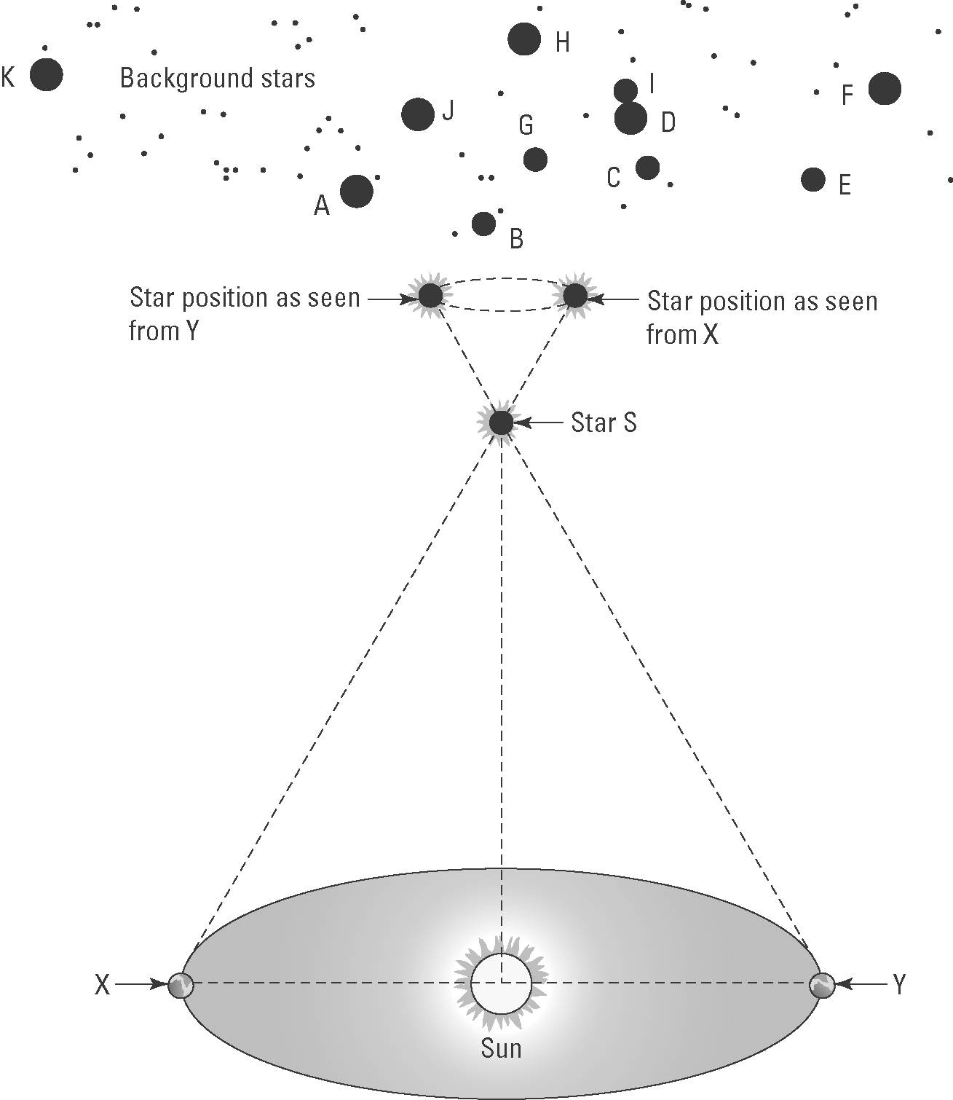
(a) The Earth is shown in two positions X and Y. How long does it take for the Earth to move from X to Y?
6 months
(b) Explain the meaning of parallax in relation to the apparent motion of stars.
The apparent movement of objects at different distances due to the motion of the observer

(c) Before 1837 it was believed that all stars existed on a transparent celestial sphere at a fixed distance from the Earth. How did the observation of parallax of close stars change this view?
The stars must be at different distances from the Earth otherwise parallax effects would not be possible.

(d) Outline the motion of the stars as seen by an observer on Earth during the time taken to travel from X to Y.
Star S appears to move relative to the fixed background stars. S will appear to the right of B, G and H from point X but 6 months later when viewed from point Y, star S will appear from the left of B, G and H.

